**Objective: Upgrade Production AML Web Service with Retrained Model from Test Environment**

**Baseline State:** Retraining on the Dev/Test has been accomplished and the new/updated .ilearner file is copied over to the Production workspace blob container (azuremlassetscontainer)

**Note**: The person executing these steps must have Contributor/Owner access in Azure and AML Workspace

**Step1**: From the Azure Portal > Production Workspace Storage account, note the URI of the updated ilearner file in the Production workspace e.g. <https://amlworkspaces1storage.blob.core.windows.net/azuremlassetscontainer/9be9bb13403044b78eaaaf0f945c8bc5.ilearner>

**Step2**: Launch Powershell: C:\>powershell

**Step3**: Login into Azure: PS C:\>Login-AzureRmAccount

Follow prompts as below:

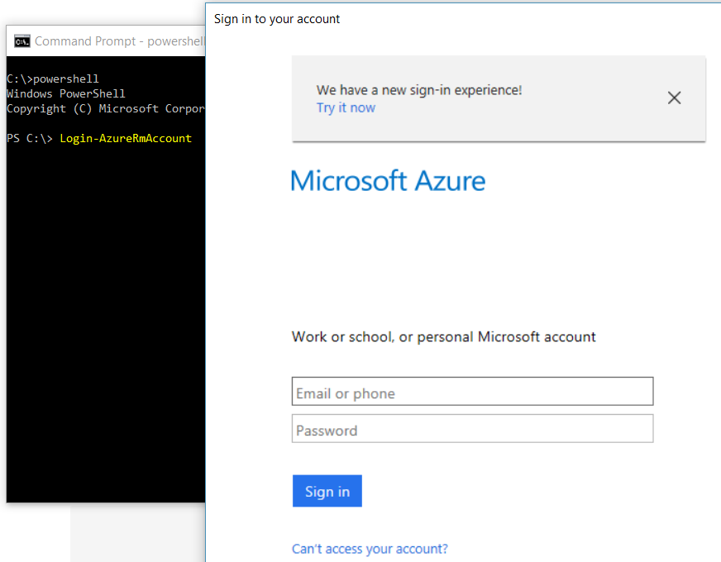

**Step4: Export the definition of the current Production Web Service**

**Step 4.a:** PS C:\>$WSD = Get-AzureRmMlWebService -ResourceGroupName "ProductionResourceGroupName" -Name "ProductionWebServiceName"

**Step 4.b**: PS C:\>Export-AzureRmMlWebService -WebService $WSD -OutputFile "C:\temp\ ProductionWebServiceName.json"

**Step5**: Carefully update the reference to the ilearner asset in the JSON to the new ilearner URI: as below – Search for “ilearner” – there should be only one in entry for this in the file.

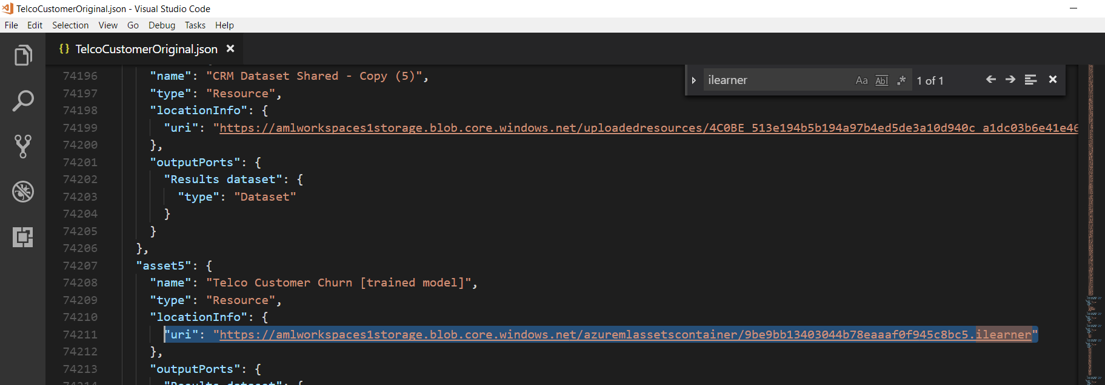

**Step6: Update the definition of the current Production Web Service**

**Step 6.a** PS C:\>$WSD = Import-AzureRmMlWebService -InputFile "C:\temp\ ProductionWebServiceName.json "

**Step 6.b** PS C:\>Update-AzureRmMlWebService -ResourceGroupName " ProductionResourceGroupName" -Name " ProductionWebServiceName " -ServiceUpdates $WSD

**Example Below:**

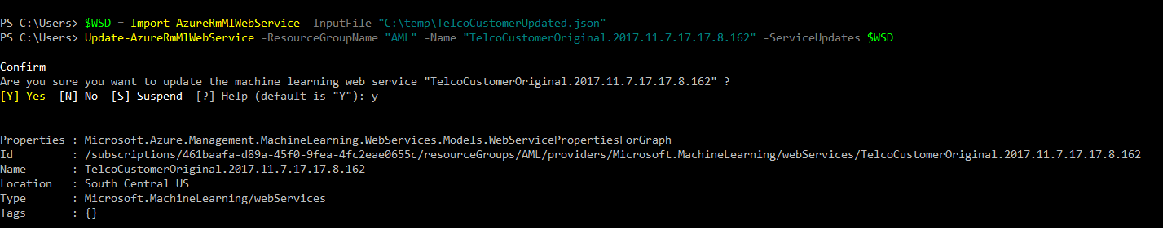

**Note:** It may take up to 50 Minutes for the updates in the web service to take effect.